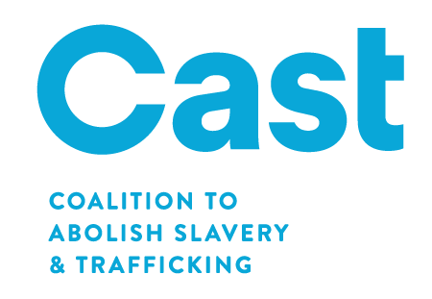
HUMAN TRAFFICKING VICTIM ASSISTANCE (HV) PROGRAM
The following twenty-one projects received Cal OES grants for fiscal year 2016-2017. Eleven projects have a 24-month grant period of April 1, 2016 through March 31, 2018 (denoted by *). The remaining ten projects have a grant period of April 1, 2017 through March 31, 2019 (denoted by **).
 | Project Name | County | Assembly | Senate
1. | Motivating, Inspiring, Supporting and Servicing Sexually Exploited Youth, Inc.* | Alameda | 18 | 9
2. | Ruby’s Place** | Alameda | 20 | 10
3. | Fresno County Economic Opportunities Commission* | Fresno | 31 | 14
4. | 1736 Family Crisis Center* | Los Angeles | 53 | 24
5. | The Coalition to Abolish Slavery and Trafficking (CAST)* | Los Angeles | 50 | 26
6. | Journey Out** | Los Angeles | 46 | 18
7. | Los Angeles - Volunteers of America** | Los Angeles | 53 | 24
8. | Y.W.C.A. of Monterey County** | Monterey | 30 | 12
9. | Community Service Programs, Inc.* | Orange | 69 | 34
10. | Women’s Transitional Living Center** | Orange | 68 | 37
11. | Stand Up Placer, Inc.* | Placer | 6 | 4
12. | C.A.S.A. of Southwest Riverside County** | Riverside | 42 | 23
13. | Opening Doors, Inc.* | Sacramento | 8 | 6
14. | WEAVE, Inc.* | Sacramento | 7 | 6
15. | Family Assistance Program* | San Bernardino | 33 | 21
16. | North County Lifeline* | San Diego | 76 | 36
17. | Asian Pacific Islander Legal Outreach** | San Francisco | 17 | 11
18. | Community Solutions for Children, Families, and Individuals** | Santa Clara | 30 | 17
19. | Verity-Compassion. Safety. Support.** | Sonoma | 2 | 2
20. | Stanislaus Family Justice Center Foundation* | Stanislaus | 21 | 5
21. | Interface Children Family Services** | Ventura | 44 | 19
Statistics were collected on both the demographics of the human trafficking victims served and the services provided. A total of 3,838 victims were served, and 153,417 services were provided (victims may receive multiple services, including of the same type).
Demographics of Victims Served: | Services Provided: | Total number of Victims  Served per County:
- Female - 3,256  - Male - 582  - Minor (ages 0-17) - 1,224  - Youth (ages 18-24) - 1,128  - With disabilities - 404  - Labor trafficked - 519  - Sex trafficked - 3,065  - Both labor and sex  trafficked - 142 | - Crisis Counseling - 36,682  - In-Person Counseling - 9,945  - Group Counseling - 27,884  - Case management - 45,846  - Shelter Services - 14,154  - Transportation - 7,401  - Legal assistance - 3,075  - Referrals to services - 7,725  - Other (not specified) - 705 | - Alameda - 303  - Fresno - 672  - Los Angeles - 1,468  - Monterey -  - Orange - 332  - Placer - 120  - Riverside - 71 | - Sacramento - 268  - San Bernardino - 207  - San Diego - 135  - San Francisco - 59  - Santa Clara -  - Sonoma -  - Stanislaus - 186  - Ventura - 17

